Ideation Phase
Empathize & Discover
Date
Team ID
Project Name | Incident Lifecycle Automation in ServiceNow
Maximum Marks | 4 Marks

Empathy Map:
An empathy map is a simple, easy-to-digest visual that captures knowledge about a user’s behaviours and attitudes.
It is a useful tool to help teams better understand their users. Creating an effective solution requires understanding the true problem and the person who is experiencing it. The exercise of creating the map helps participants consider things from the user’s perspective along with his or her goals and challenges.

Project-Specific Empathy Map
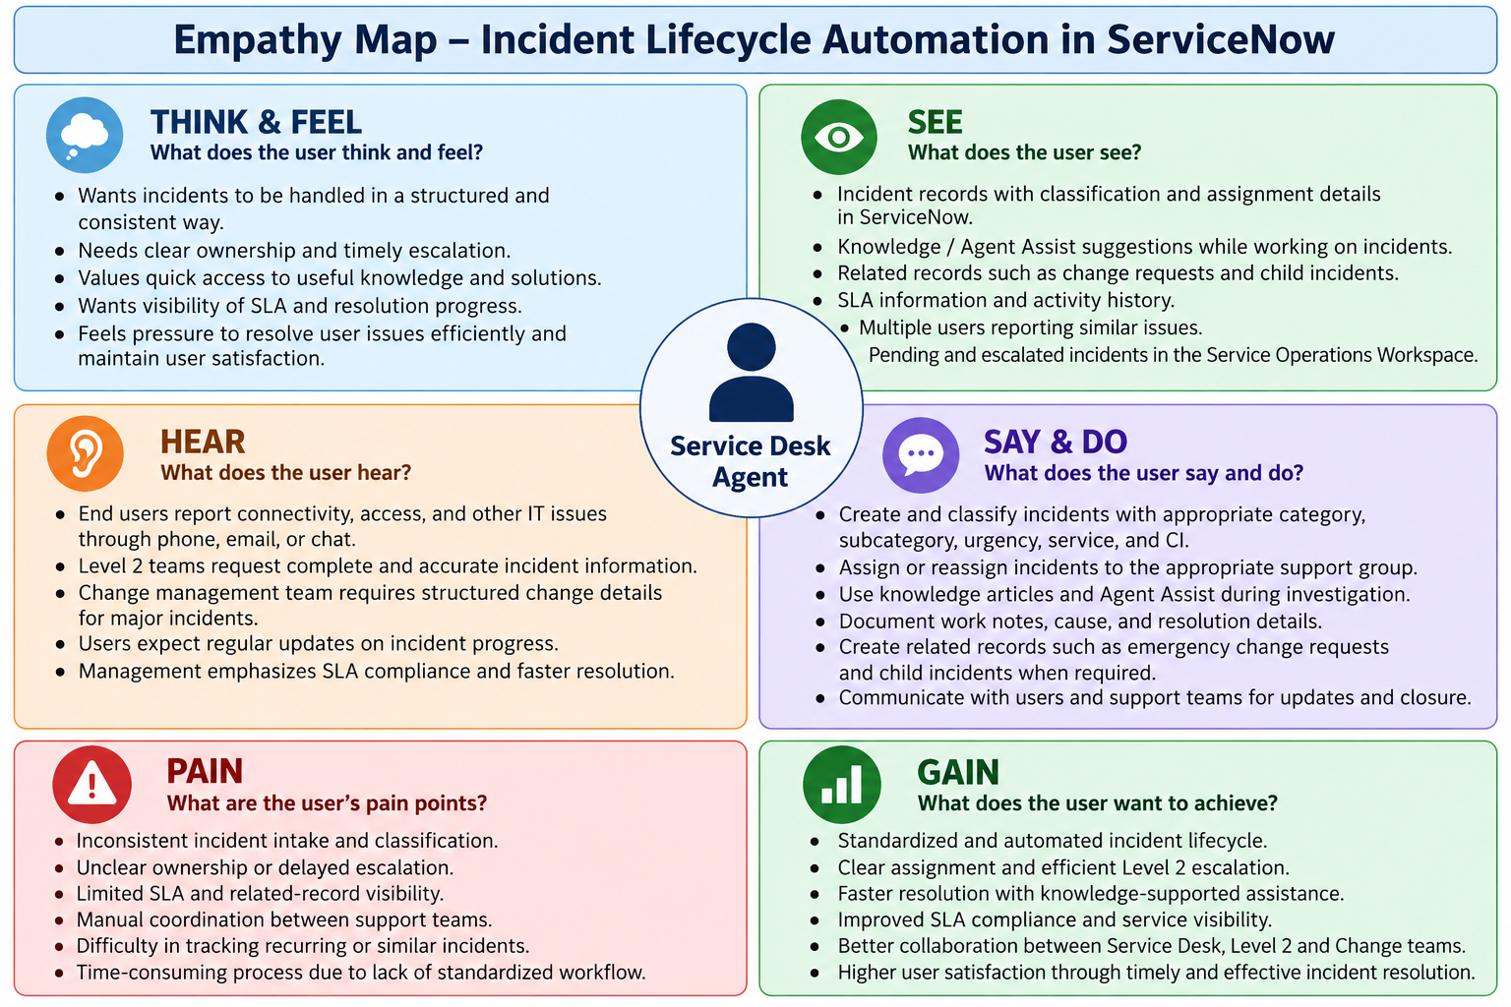

User perspective selected: Service Desk Agent. The map reflects the project’s defined incident-management activities, including incident creation and classification, knowledge support, assignment/reassignment, Level 2 investigation, change integration, child incidents, resolution documentation, knowledge creation, and SLA tracking.

Empathy Map – Detailed Interpretation
Empathy Map Area | Service Desk Agent Perspective | Project Relevance
Think & Feel | Wants structured incident handling, clear ownership, timely escalation, useful knowledge, and visibility of SLA and resolution progress. | Supports consistent Incident Management and improved coordination.
See | Sees incident classification and assignment details, Knowledge/Agent Assist results, related records, and SLA/activity information. | Provides the information needed for investigation and tracking.
Hear | Receives issue reports from end users and information/requests from Level 2 Support and Change Management. | Supports communication and collaboration across stakeholders.
Say & Do | Creates and classifies incidents, assigns/reassigns them, uses knowledge, documents work, and creates related records when required. | Represents the operational activities defined in the project scope.
Pain | Inconsistent intake/classification, unclear ownership, delayed escalation, limited SLA visibility, and manual coordination. | These are the project problems the ServiceNow lifecycle addresses.
Gain | Standardized lifecycle, clear ownership, knowledge-supported resolution, Level 2 escalation, and improved SLA/related-record visibility. | These gains align with the stated project objectives and goals.

Empathy Map Outcome
The empathy mapping exercise identifies the Service Desk Agent’s needs and challenges within the incident lifecycle. It supports the project objective of standardizing and automating Incident Management in ServiceNow while maintaining clear ownership, escalation, knowledge support, related-record tracking, and SLA visibility.

